The Friends of Wisbech & Fenland Museum

Winter Lecture Programme
Wednesday 1 February 2017 at 1pm
The Exotic World of The Georgian Theatre
an authoritative and informative talk by
Jacqueline Mulhallen
Forget the wigs and fans and sipping tea! At the Georgian theatre you could be transported from London to China and from the South Seas to the storming of the Bastille – shipwrecks, storms, explosions – here is the forerunner of the Hollywood blockbuster, the documentary, the dramatisation of novels and poems. All in mime, dancing and acrobatics – hear all about it!
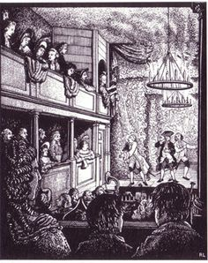
Dr. Jacqueline Mulhallen is an actor and playwright as well as the author of two books on Shelley

Friends of Museum
& students…….Free entry

Non-members…………..£3
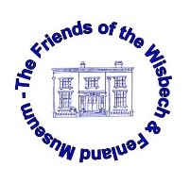
friendsofwisbechmuseum@outlook.com

